**WT Assignment 1:**  
GITHUB repository and folder creation steps:

**Step1:** Search github.com in any browser and open the site.

**Step2:** Register or login to your account using your email.

**Step3:** Press ‘create repository’ button on homepage and fill all details like repository name etc. to create a new repository.

**Step4:** To add folders to the repository, click ‘add new file’ on home page, then click ‘create new file’ and name it like ‘folder_name/any_file_name’ to create a folder as GitHub does not allow to make empty folders.

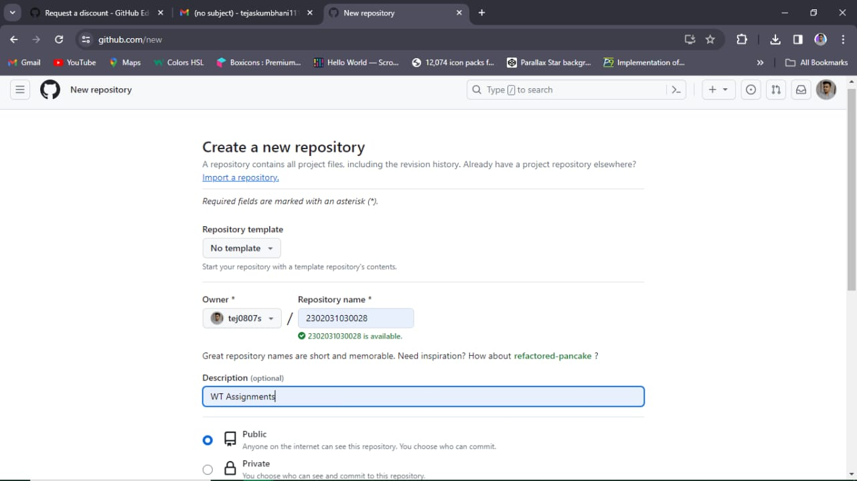**Steps Visual Guide:**

